<https://msdn.microsoft.com/en-us/library/ff799534(v=vs.110).aspx>

https://msdn.microsoft.com/de-de/library/system.windows.controls.ribbon.ribbon(v=vs.110).aspx

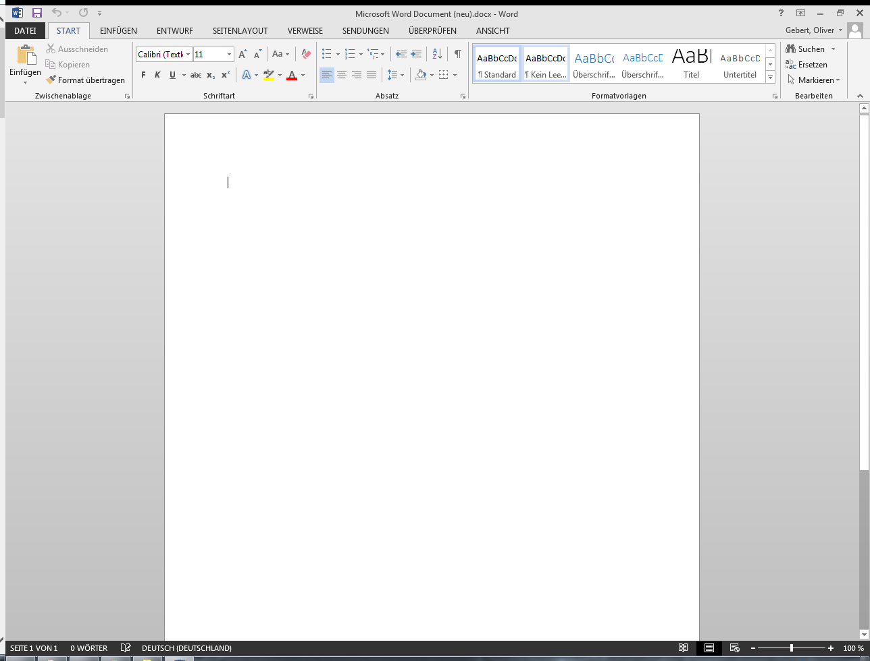

1. quick access toolbar
2. Ribbon Tabs
3. Application menü
4. Help pane content
5. Ribbon-Groups

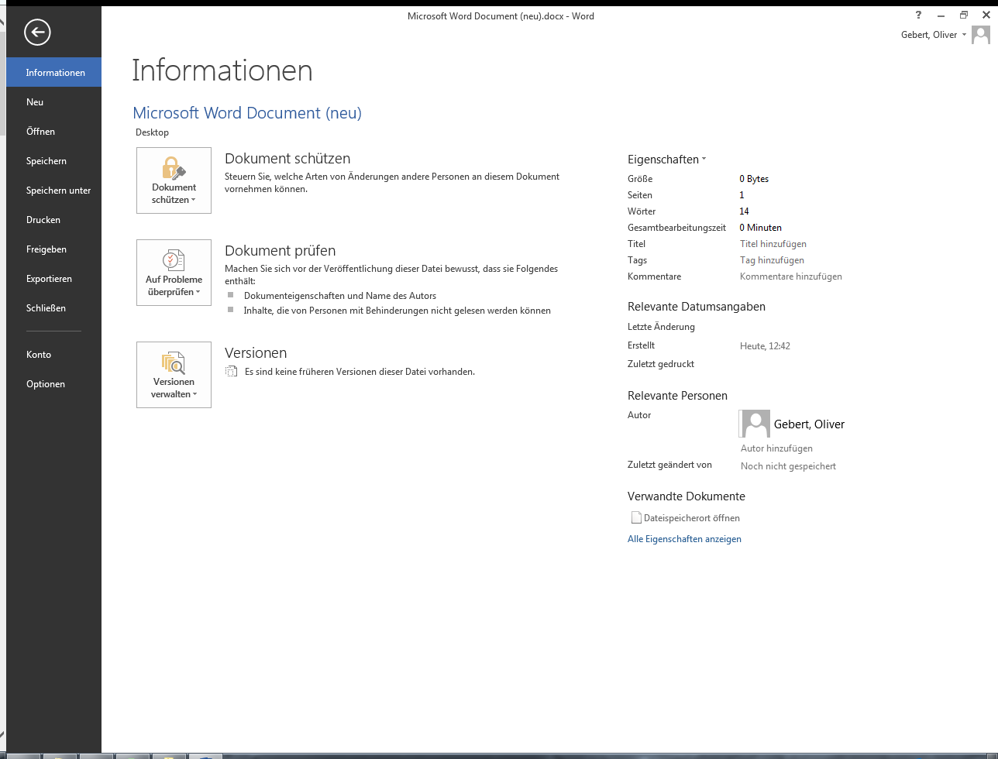

1. [RibbonApplicationMenuItem](https://msdn.microsoft.com/de-de/library/system.windows.controls.ribbon.ribbonapplicationmenuitem(v=vs.110).aspx) Menü Items
2. [AuxiliaryPaneContent](https://msdn.microsoft.com/de-de/library/system.windows.controls.ribbon.ribbonapplicationmenu.auxiliarypanecontent(v=vs.110).aspx)
3. [FooterPaneContent](https://msdn.microsoft.com/de-de/library/system.windows.controls.ribbon.ribbonapplicationmenu.footerpanecontent(v=vs.110).aspx)

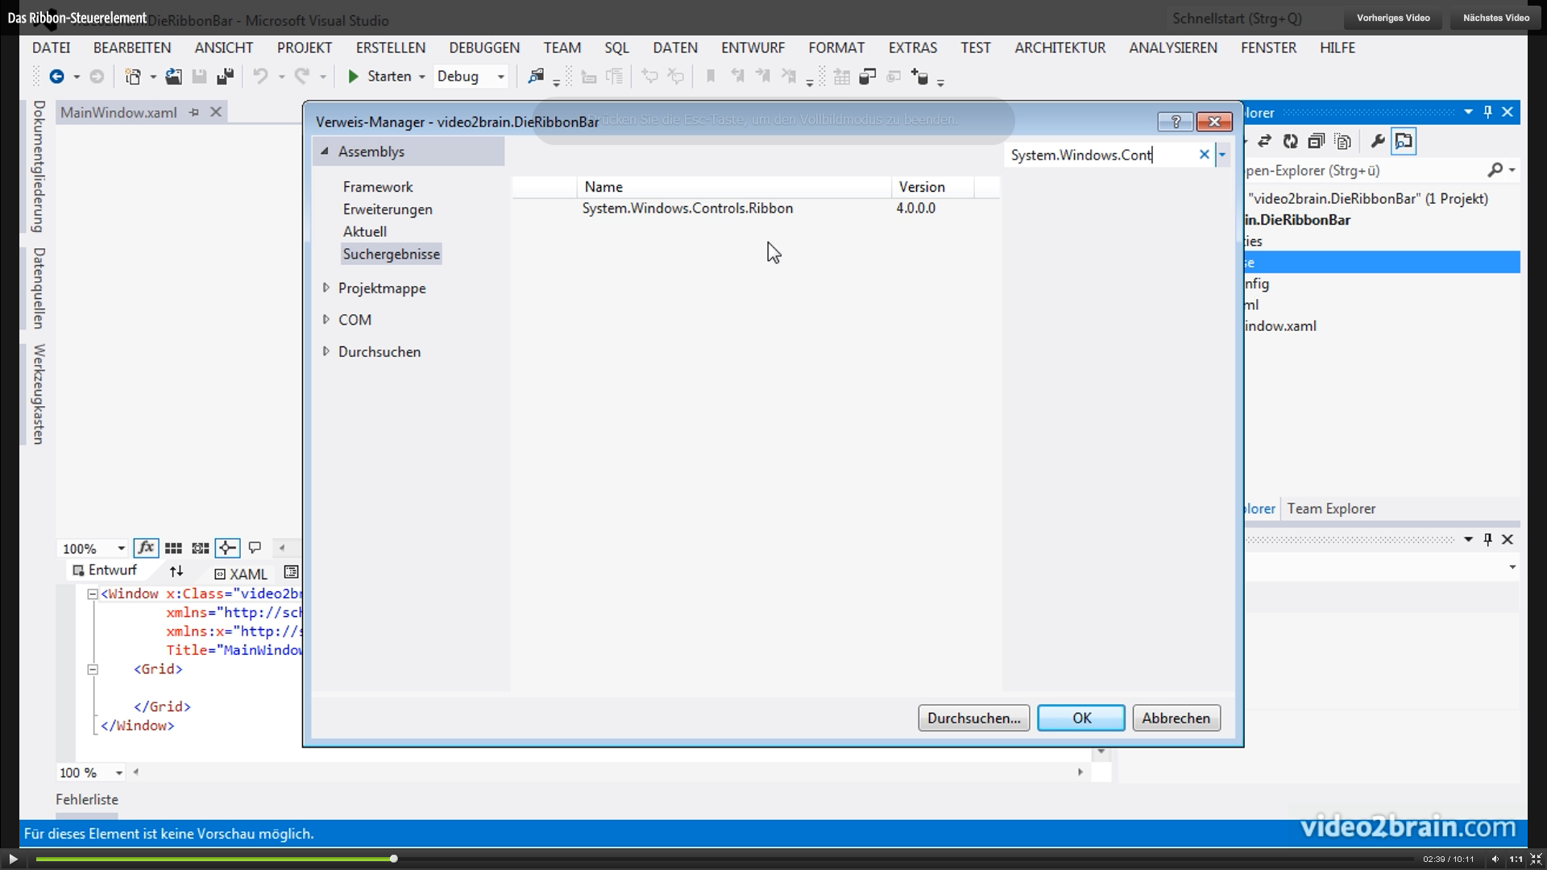

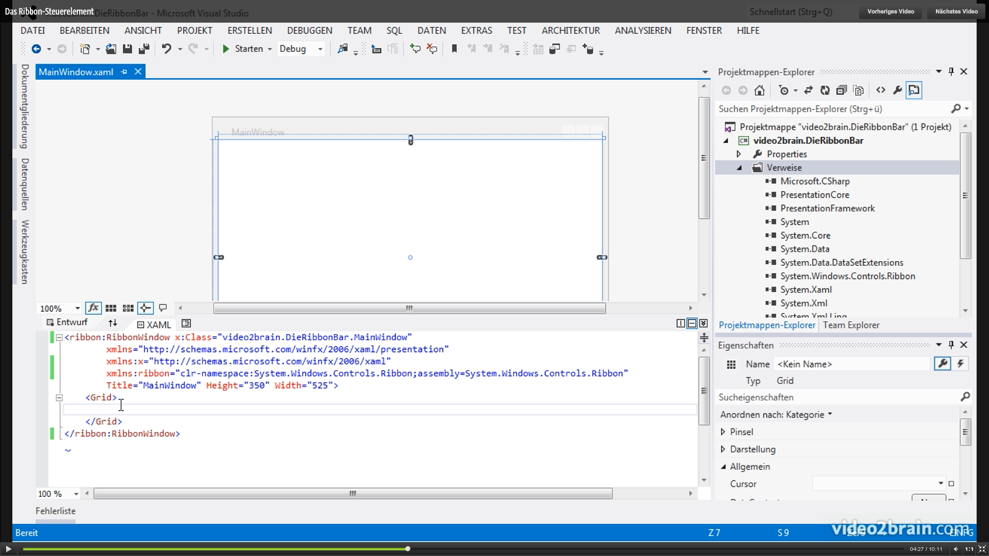

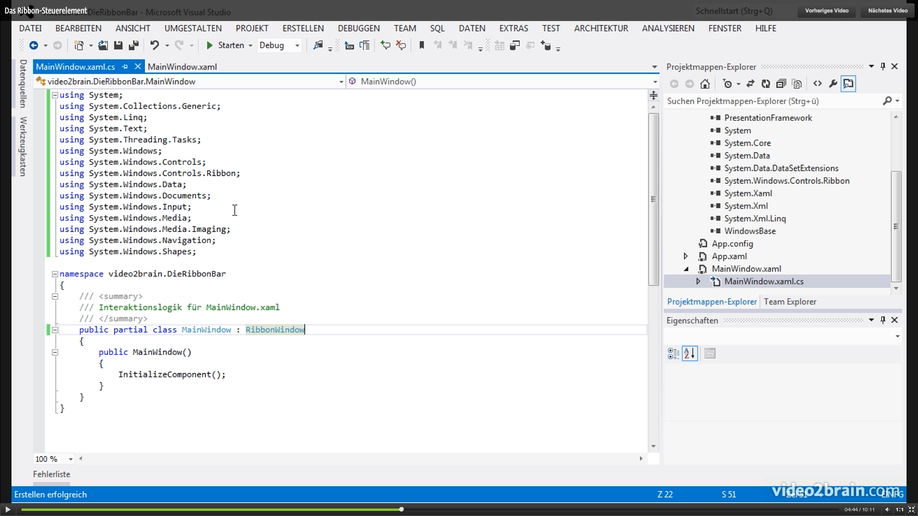

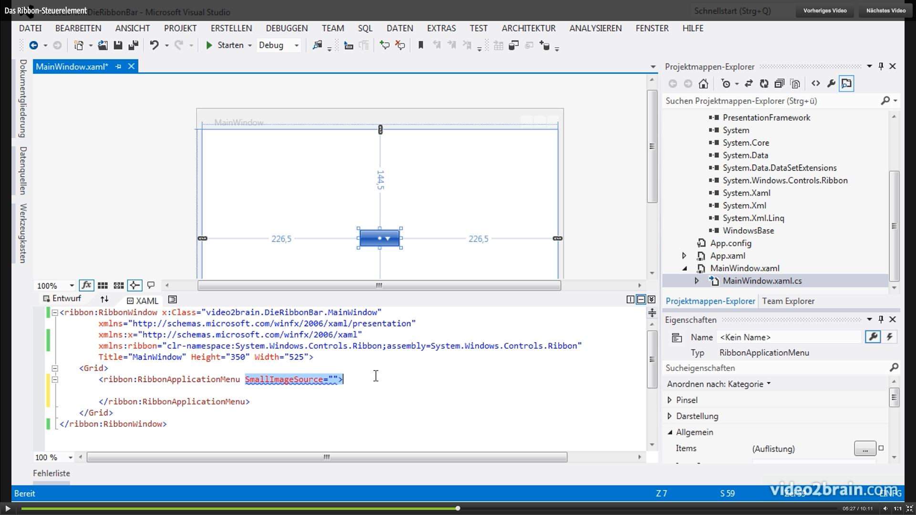

Icon im Menü zeigen

